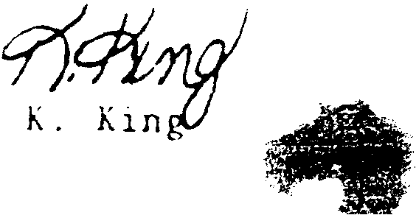
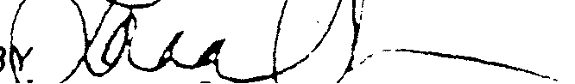

California Division
REPORT OF TEST
NUMBER
TO:
Western Flame Safe 2197 North Street Anderson, CA 96007
LA 31383 9/20/83
CT: Fire Retardant Chemical
REFERENCE:
Client's confirmation dated 8/19/83 signed by D.E. Munns.
SAMPLE IDENTIFICATION:
One sample submitted and identified by the Client as fire retardant chemical and six Douglas Fir branches.
TEST REQUEST AND METHOD:
Flammability per California Administrative Code, Title 19, Public Safety, Article 3, Section 1264.3, "Christmas Trees" and referenced Section 1237.1 (Small Scale Test).
The chemical was applied in accordance with the Client's instructions. A hand activated spray bottle was used to apply a light coating of the chemical. The chemical was allowed to become tacky on the branches and then a second coat was applied until the branches were completely saturated.
The treated and untreated branches were aged at the following conditions (monitored during the working day).
Temperature Relative Humidity
73.4±1.8PF 50±2%
The test was peformed after a 30 day aging period.
Technic ian :
s1
SIGNED FOR THE COMPAN'r'
I
B /-_______..
Lorna Ozaws, Manager
Material, Textiles
"'-"w Y"rl.. Chll cl~l' • t '" ""I""" ,\'l"lllpll'<_ K",'II'lll' "" I",,,,,
' •.•• , INC •• (ro.,s A_a L(11La\ •• r rOI IHI t'(~U')I ••. t L\.l Ut 1 •••• (.LI(,..l 10 ••.• u. It'lf' •• 1 Alli.i1. ",~ •.•• l' IHI1 .•••• 1
11S,1 ••• ", co.,. •.• , ' •• C O. III S14.llo o. 'flrII~I"''''''J,. .11 "'u~ 1~1 .1 Ulloll.1 u"O(tl: •.•• , ~_'''Ltl.,>t'''''ll ':. t ••• Li •• l.'f\tllt •... 1 ~+.,
(0 ••• U.'(6110,", 10 .••• T 01" •• \ 0.1"1 U\I 01 , •• , "'" •• , (' .•...• "nltL- ~I.lll" If\II •••• L •• (11 •. 1 Oull r- •• ,u.
O.t·~ "'''''l' O_ll TO 1Nt \1 •• 0 ••. aD\ 0_ '.Ui.lLJU." ILJl",I,! r o .•.• (j 1( l •.• ! \ •••• ~{\ 1',;[, .•.•.• rlr". _ ••.•
IMI 1(1T ."010_ 1"~I"I~ flO", JIIIl\l.d!', A. loI'

United States Testing Company , Inc:
CLIENT:
Western Flame Safe
Number LA. 31383
RESULTS:
Afterflame. sec.
0.0
0.0 0.0 .

PHYSICAL:
The treated branches did not lose needles or turn brown at a rate greater than the untreated branch.
REQUIREMENT:
e
There shall be no spread of flame from the area it contact with the test flame and any afterflaming shall not exceed 10 seconds. At the completion of the 30-day.aging period, the treated branch shall not lose its needles more readily nor shall they have turned brown to a greater extent than those of the untreated branch similarly aged.
COMMENT:
The submitted chemical meets the requirements of Title 19 Section 1264.3 for use on Douglas Fir trees

NOTE: The sprayed branches remained tacky after drying and did not lose the tacky feeling during the 30 day aging period.

